Propaganda Posters
Propaganda is a form of communication that is aimed at influencing the attitude of a community toward some cause or position so as to benefit oneself or one's group. Propaganda is often biased, with facts selectively presented to encourage a certain opinion, or uses loaded messages to produce an emotional rather than rational response to the information presented. The desired result is a change of the attitude toward the subject in the target audience to further a political, or other type of agenda. Propaganda can be used as a form of political warfare.
Examples of Propaganda Posters

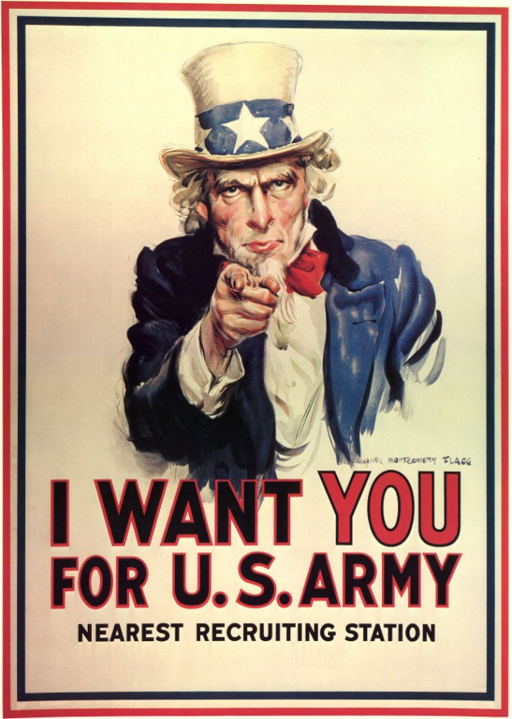
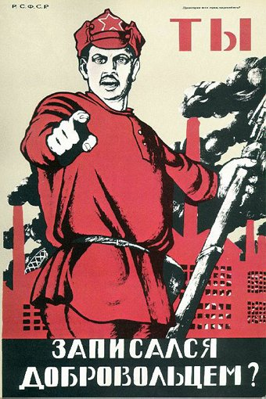
American recruiting poster depicting Uncle Sam, persuading men to join the army to fight in the war.
Dmitry Moor's famous poster translates to mean "Have You Enlisted In the Army?" The image of a Red Army soldier with plumes of black smoke rising from the factory smokestacks in the background. It questions the Russian worker about his contribution to the defense of the October Revolution.

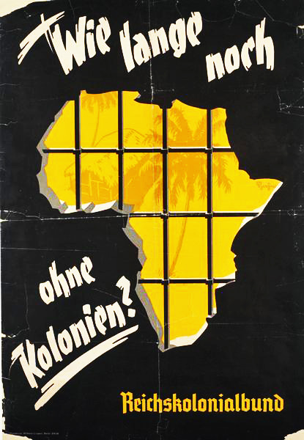
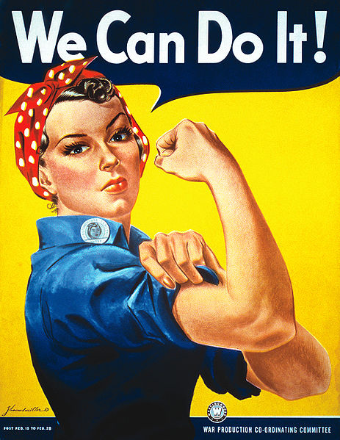
Poster of “Rosie the Riveter” encouraging women to aid the U.S. war effort by taking men's jobs at factories.
Translation: How much longer without colonies? (after the Treaty of Versailles) Until the Treaty of Versailles, Germany had been one of the minor colonial powers in Africa. From 1936, the supporters of the reclamation of these colonies were organized into the "Reichskolonialbund" (The National Colonial Association) which created this poster, showing how Germany is shut out with iron bars from the promises of Africa.

Propaganda Posters
Choose one option below, to create a propaganda poster about the Russian Revolution or the German response to the Treaty of Versailles. Remember what the goal of propaganda is; to persuade your audience to agree with your opinion. For a poster, you are using images and only a few words to persuade your audience. Then using the space provided, write a short paragraph explaining your poster.
Option A: Pretend you are a Russian peasant or communist living during the time of the reign of Czar Nicolas II. You agree with the reasons why the Russian people should revolt (hint- you must know the reasons why the Russians wanted to revolt against their government- Check your handouts and notes if you can’t remember). Create a poster convincing your fellow Russians to join your cause. Make sure they understand your reasons for revolting based on the images you choose to draw.
Option B: Pretend you are a member of the Russian Royal Family (The Romanovs), and you believe that the monarchy (a government with kings and queens) should remain (hint- you must remember the movie we watched on the Russian Revolution and what role the Romanovs played - Check your handouts and notes if you can’t remember). Create a poster convincing your fellow Russians to join your cause. Make sure they understand your reasons for keeping the Czar and monarchy based on the images you choose to draw.
Option C: Pretend you are a German citizen and it’s just been announced that Germany must sign the Treaty of Versailles. You feel very strongly that the treaty is too harsh on Germany. Create a poster convincing your fellow Germans to reject the treaty (hint- you must remember what the Treaty of Versailles is and how it affected Germany- Check your handouts and notes if you can’t remember). Make sure they understand your reasons for not signing the Treaty, based on the images you choose to draw.
Option D: Create your own! (get teacher permission)

